**FitPick**

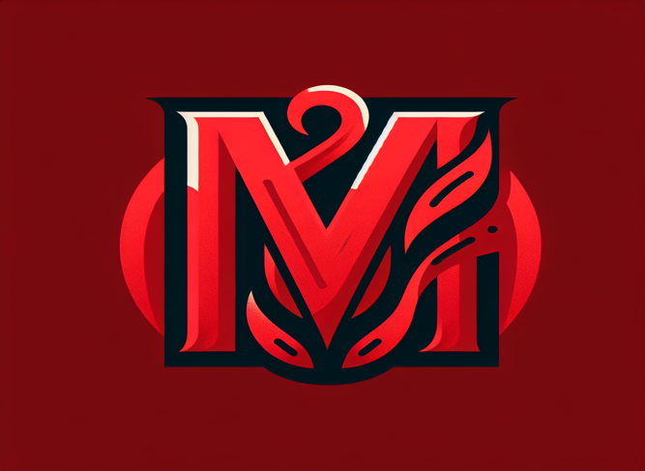

**Summary**

A web app stores your outfits with descriptions and picks at random. An easier way for you to manage your closet digitally instead of needing to remember all the pieces you have and also a way to keep track of your best outfits.

**Technologies**

NextJS

**Database and account storage**

Firebase?